Quiz NO : 1

Course : DataBase Management

Given to : Sir Syed Hassan Zaidi

Group Members:
Umair Hayat BAI-25F-033
Saad Bin Riaz BAI-25F-035
Karan Kumar BAI-25F-099
Naresh Kumar BAI-25F-032

Query NO: 1

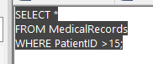

Output >>>
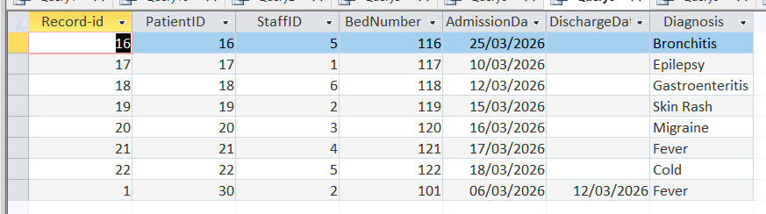

Query NO: 2



Output >>>
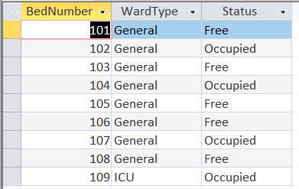

Query NO: 3



Output >>>
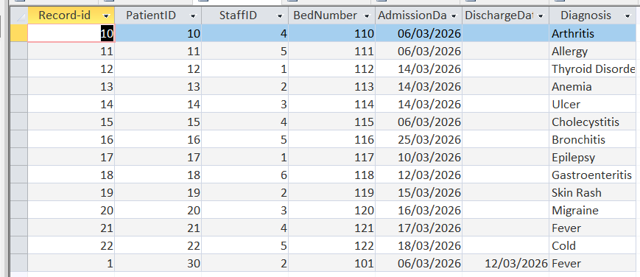
Query NO: 4

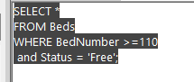
Output >>>
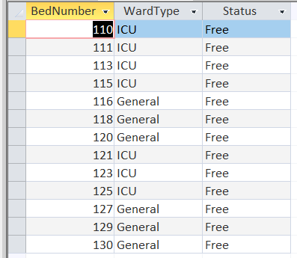

Query NO: 5

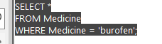

Output >>>


Query NO: 6

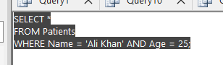

Output >>>

Query NO: 7



Output >>>
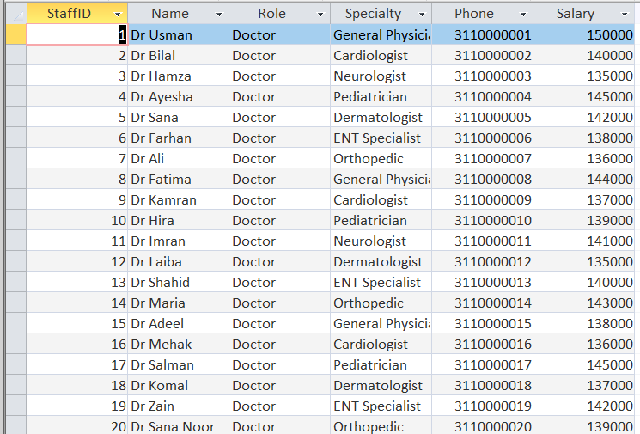

Query NO: 8

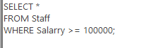
Output >>>
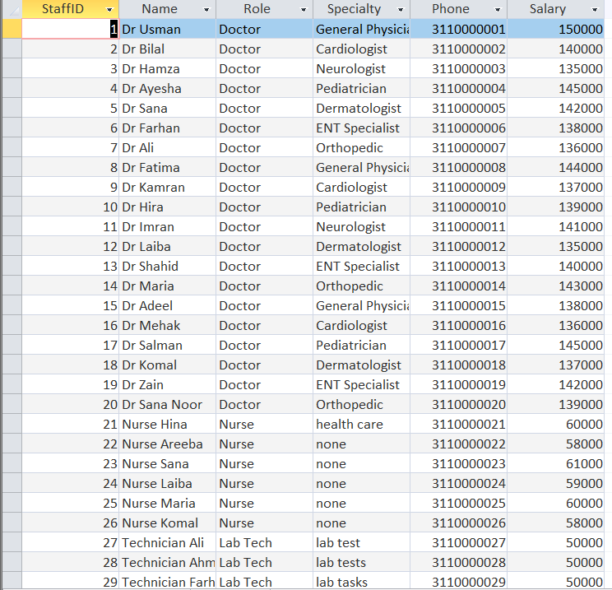

Query NO: 9

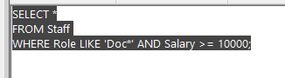

Output >>>
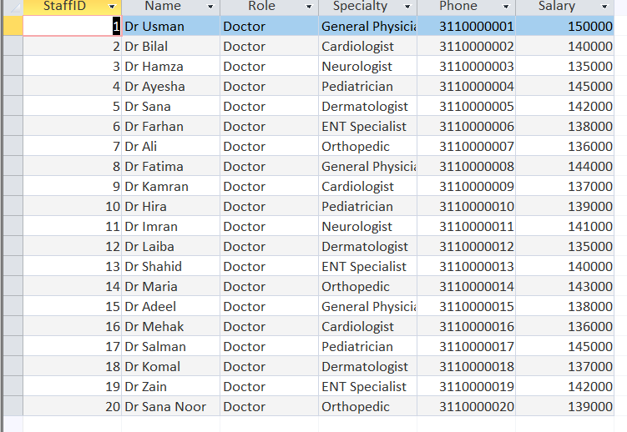

Query NO : 10

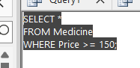

Output >>>
